**DRESS APPLICATION PROJECT**

**SDLC LIFE CYCLE**

**REQUIREMENT GATHERING**

* This project is based on the stock management
* Web project
* Stock details
  + **Dress quantity**
  + **Dress id**
  + **Dress price**
  + **Brand name**
  + **Brand id**
  + **Brand country**

**PLANING**

* This project is used to monitor the dress stocks
* Cost for making this project is 5000
* Time for completing this project is **one month**
* Scrum meeting weekly basis
* Team members :3
* Team lead :1
* **Technical stack:**
  + Github
  + Eclipse IDE or Vs code
  + Java (maven project)
  + Spring boot
  + Rest API or Graph ql (postman)
  + Database: mySql
  + Tomcat server
* **SRS Documentation** should be done

**DESIGNING**

* As we are using mysql,
* Database name should be **Dress_db**
* Two tables needs to created by having the name **dress_table** and **brand_table.**
* In spring boot ,Service class is optional
* Required attributes for dressdto -**dressId(primary),dressPrice,dressQuantity,brandId(foreign)**
* Required attributes for branddto-

**brandId(primary),brandName,country**

* **Github** should be used.
* **Multiple Endpoints**
  + Save
  + Getbyid
  + Getby quantity
  + Getby quantityandprice
* Creation of Api in postman using <http://localhost:8080/dress_restapi/save>

<http://localhost:8080/dress_restapi/getbydqandprice?dq=10&price=3550>

* Designing should be completed within 1 week
* Create the **DDS documentation**

**Workflow**

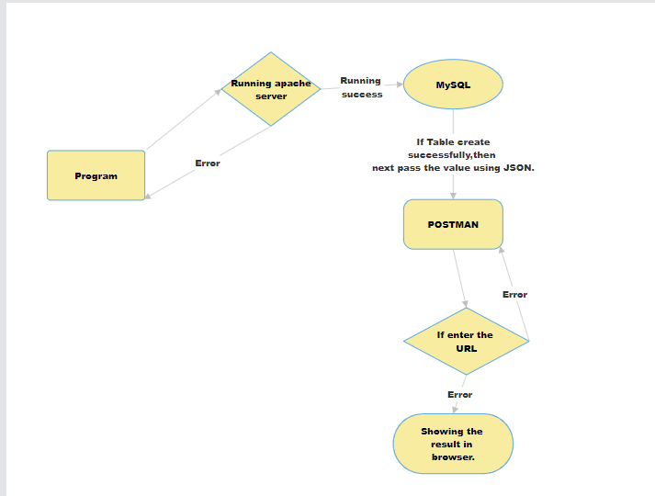

**CODING**

* Download the **dependencies** based on all the required needs.
* Generate the **maven project**
* Creating all the classes required for the project includes **dto,repository,dao ,controller.**
* **Unit testing** should be done
* Coding should be completed within **1week**
* Creating the documentation

Dress Application

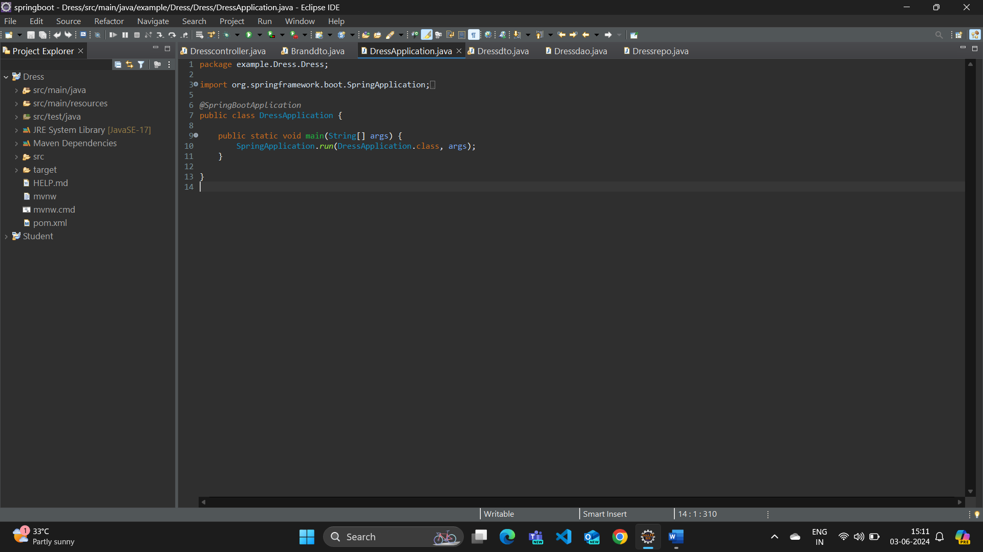

Dto class for dress Entity

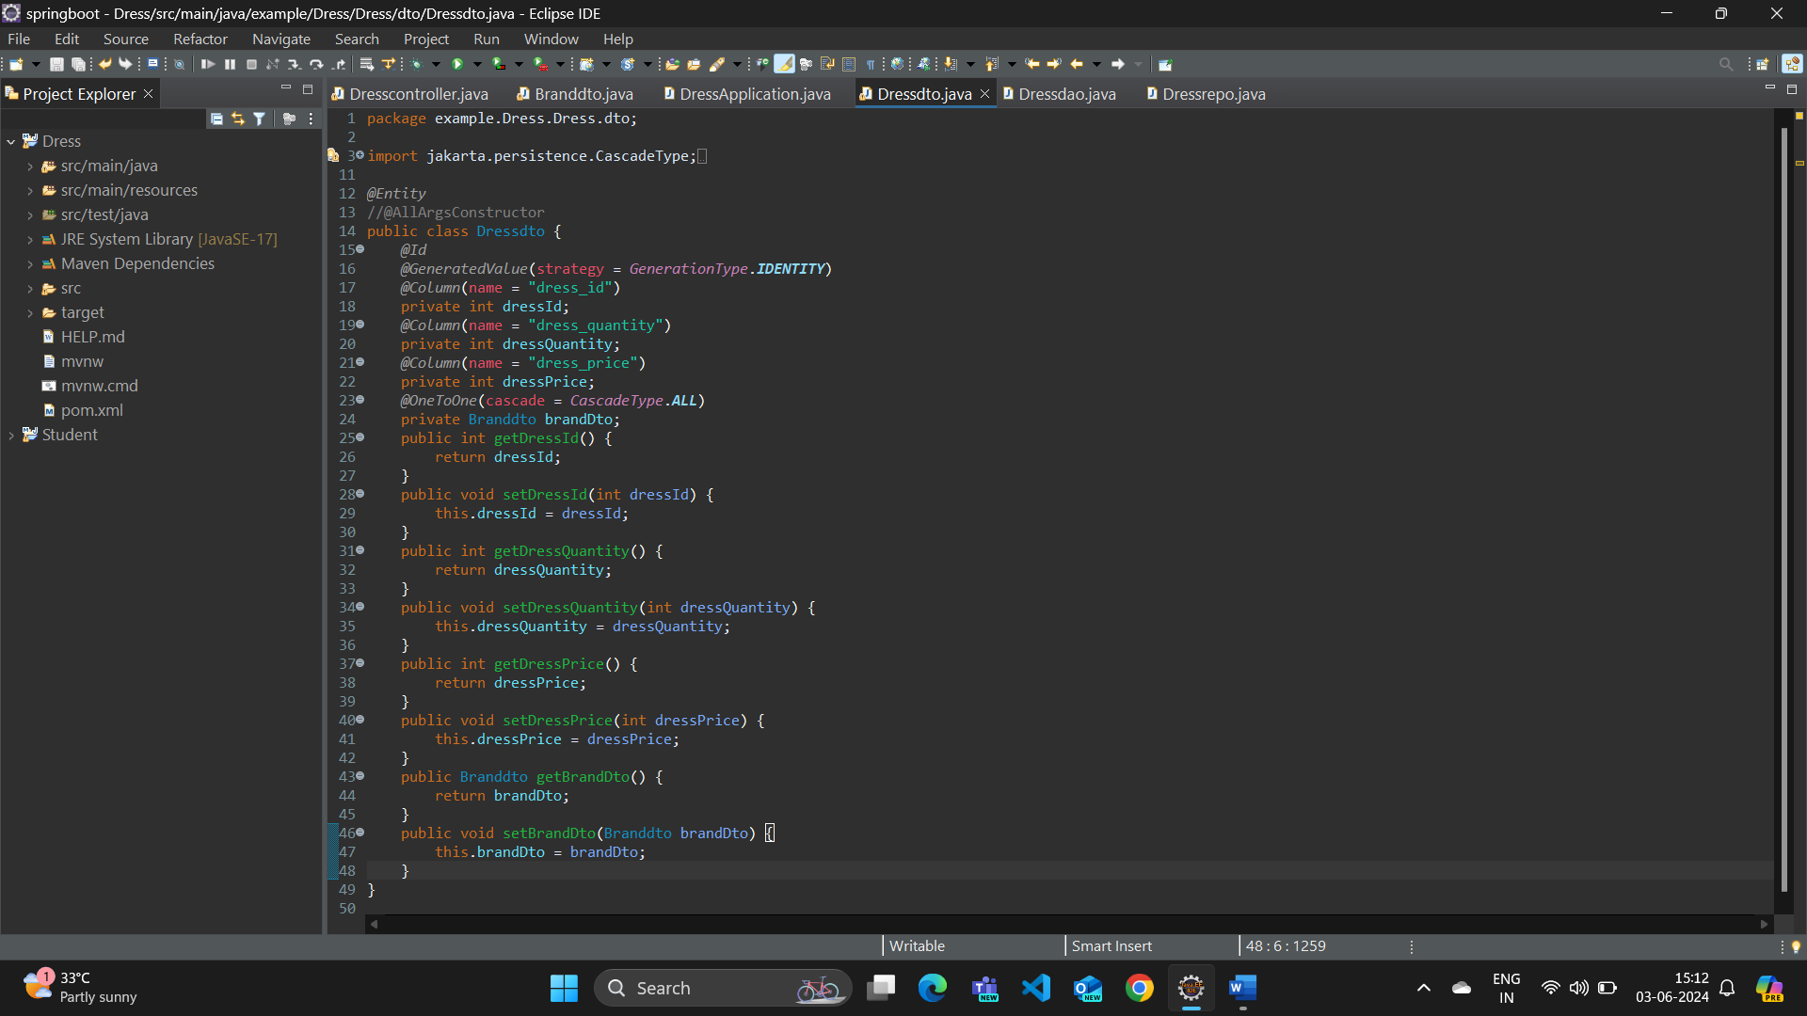

Dto class for Branchdto

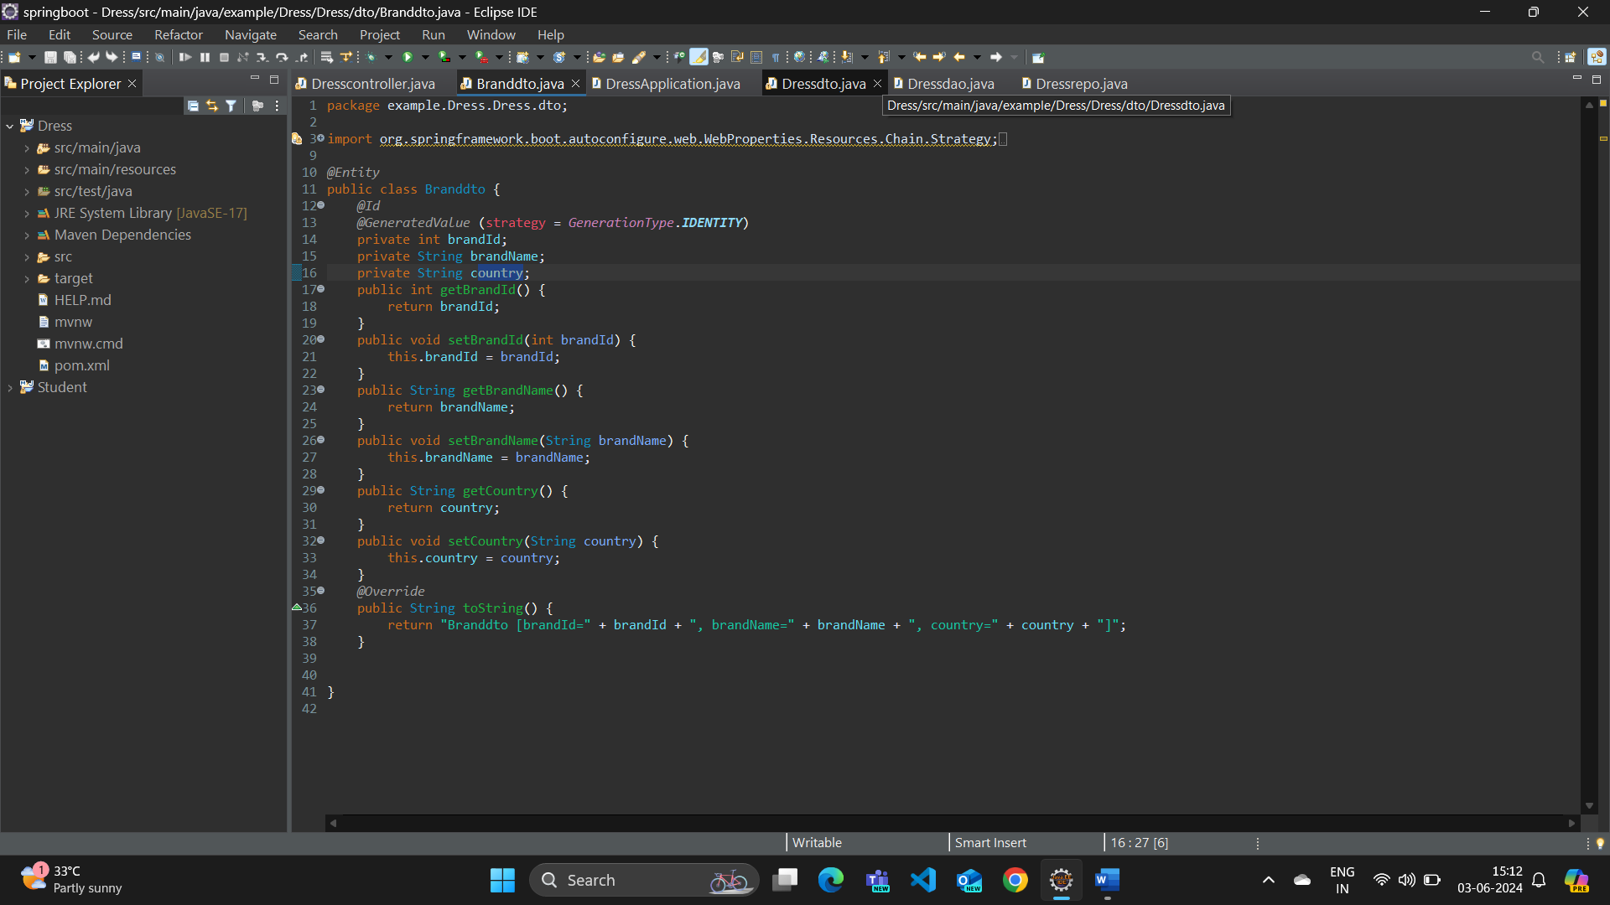

Repo for dress

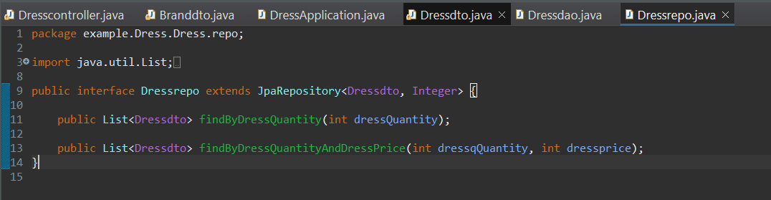

Repo for Brand

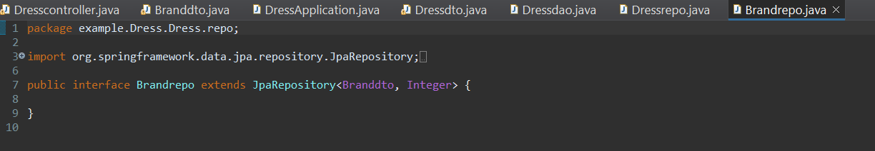

Dao class

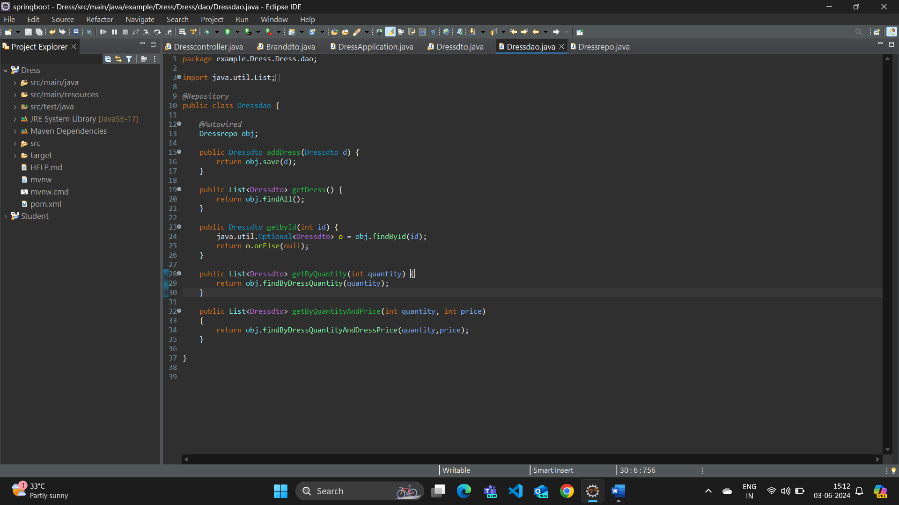

Controller class

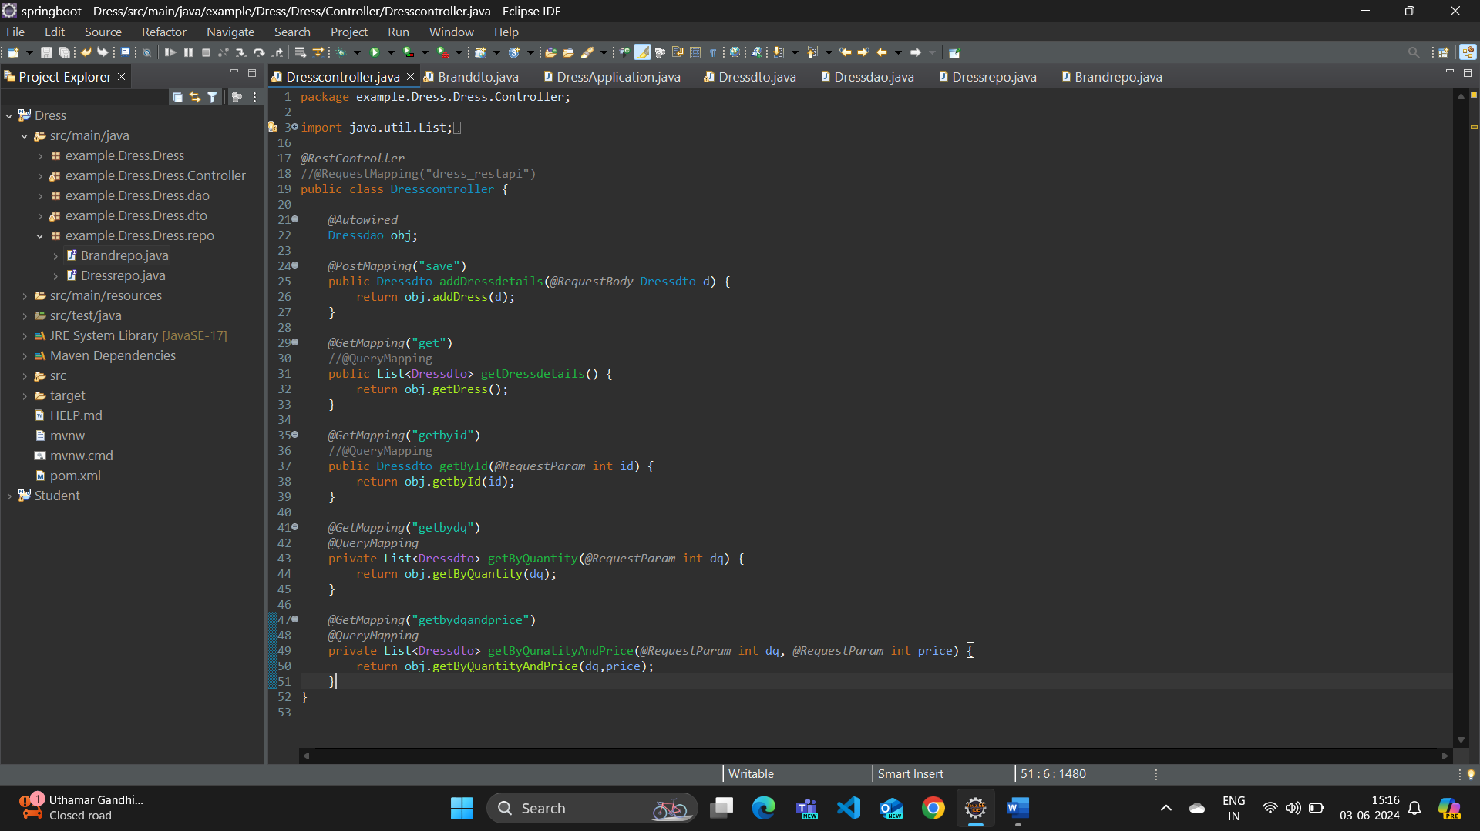

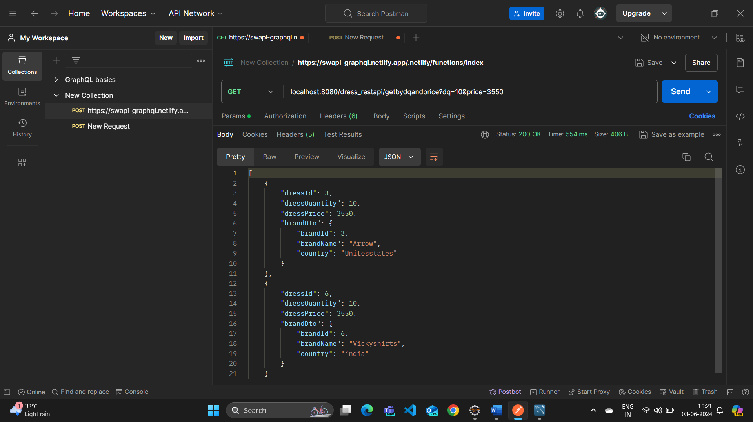

**TESTING**

* Using stlc cycle Testing should be done
  + Testing based on every attributes
  + Testing based on compatibility
  + Testing based on use load(durability)
  + Testing based on Security
* **System Testing** should be done
* Errors and bugs should be reported to the developer team
* Documentation should be created for every bugs identified
* Errors should be addressed , reported and modification should be done within **1 week.**

**DEPLOYMENT AND MAINTENANCE**

* Releasing the product at specified time
* **Feedback** forms should be collected and analysed
* Demo should be done before the Deployment process
* Client needs to be Satisfied with the product
* New features should be analysed from users feedback and implemented
* Launching should be done before the end of last week